MODELLING OF WATER SYSTEMS FOR PLANNING OF SUSTAINABLE DEVELOPMENT
Aivars Spalvins, Janis Slangens, Romans Janbickis, Inta Lace.
Environment Modelling Centre, Riga Technical University, Latvia
e-mail: emc@egle.cs.rtu.lv

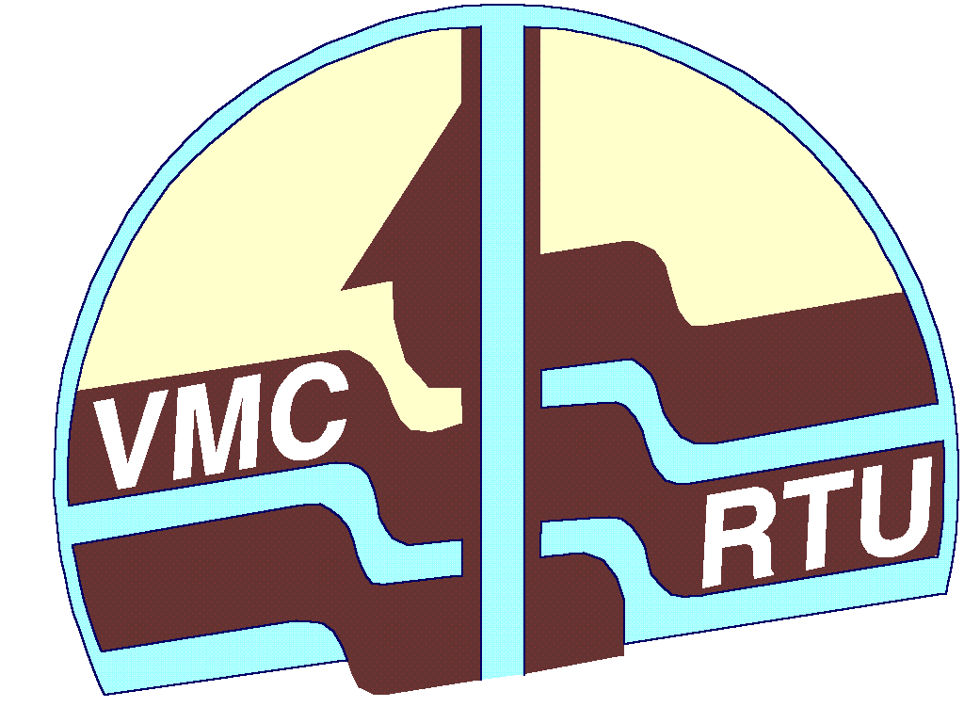

The water Framework Directive of EC declares that a river drainage basin must be applied as a base for sustainable management of water resources. For small Baltic countries, these basins are transboundary.

Modelling tools are available for elements of the hydrologic cycle (Fig. 1) and for water systems of large towns (Fig.2).

Most of time to create a model is spent to validate initial data. If these data are scarce then no model can provide reasonable results.

A modeller should possess a skill to apply a software tool, especially, when migration of pollutants is considered (Fig. 3).
Fig. 3. The 3D model of pollution migration from Incukalns sulphur –sludge pools towards the Gauja river (model sreated by EMC in 1998, renovated in 2004–2005)
Since 1992, the Environment Modelling Centre (EMC) of the Riga Technical University has been dealing with models of waterworks and migration of pollutants.
Even for small transboundary models, it is not easy to obtain concordant hydrogeological data from the bordering countries. Similar problems arise when a model includes sea and land areas, because data of these areas are not concordant.
On deep confined aquifers, the river basin has little impact. Then their models may include several basins, covering the area considered.

