PREVENTING SEAWATER INTRUSION INTO
A WELL FIELD OF LIEPAJA

Aivars Spalvins, Janis Slangens, Romans Janbickis, Inta Lace
Riga Technical University, Faculty of Computer Science and Information Technology,
Environment Modelling Centre


.
Formerly (from 1950 to 1970), due to water supply (~15000m³/day) of Liepaja from the Devonian D3zg aquifer laying beneath the town, it become contaminated by sea water (chlorides). In 1960, the well field Otanki has been constructed outside the town and groundwater taken from the aquifer here is still of excellent quality.

In 2003, a hydrogeological model (HM) was created to investigate possibility to enlarge (4800m³/day →3×4800m³/day) the Otanki withdrawal. Without protection measures, chlorides will intrude the Otanki field. Their migration may be stopped by applying special wells discharging chlorides. By using HM, the number, disposition and regimes of these wells have been found.

D3zg

. Cross section EF of the hydrogeological model
.

Piezometric head [m asl] distribution for the D3zg aquifer, in 2002. The Otanki rate was 4800m³/day. Part of production wells was too close to the chloride contaminated area.
The Devonian aquifer beneath the Liepaja has been intruded by chlorides.

The plane step of HM was 150m, HM contained 9 grid planes of size 14.7km ×14.7km.

By using special wells, to discharge chlorides, their migration towards Otanki can be stopped.

.

The present cloride distribution [mg/l] for the D3zg aquifer. Configurations of chemical protection zones if the production rate is 4800 m³/day (line 1) and 3×4800m³/day (line 2)

Piezometric head [m asl] distribution for the D3zg aquifer when the Otanki production rate is 3×4800m³/day Three wells must discharge chlorides to prevent their migration towards production wells, which disposition is changed to more optimal.

Modelled distributions of chlorides after 25 years yearsyyearsyears

.
.
.

To stop chloride migration towards the Otanki field, when its withdrawal is 3×4800m³/day:
- disposition of its production wells should be changed;
- special wells should be applied to discharge chlorides.

Intrusion of chlorides will be limited if the system for their discharge 1950m³/day will be applied
Intrusion of chlorides will be stopped if two systems of discharge wells will be applied. Their total rates-1950m³/day and 600m³/day
Chlorides will enter the well field if no protection against their migration will be applied.

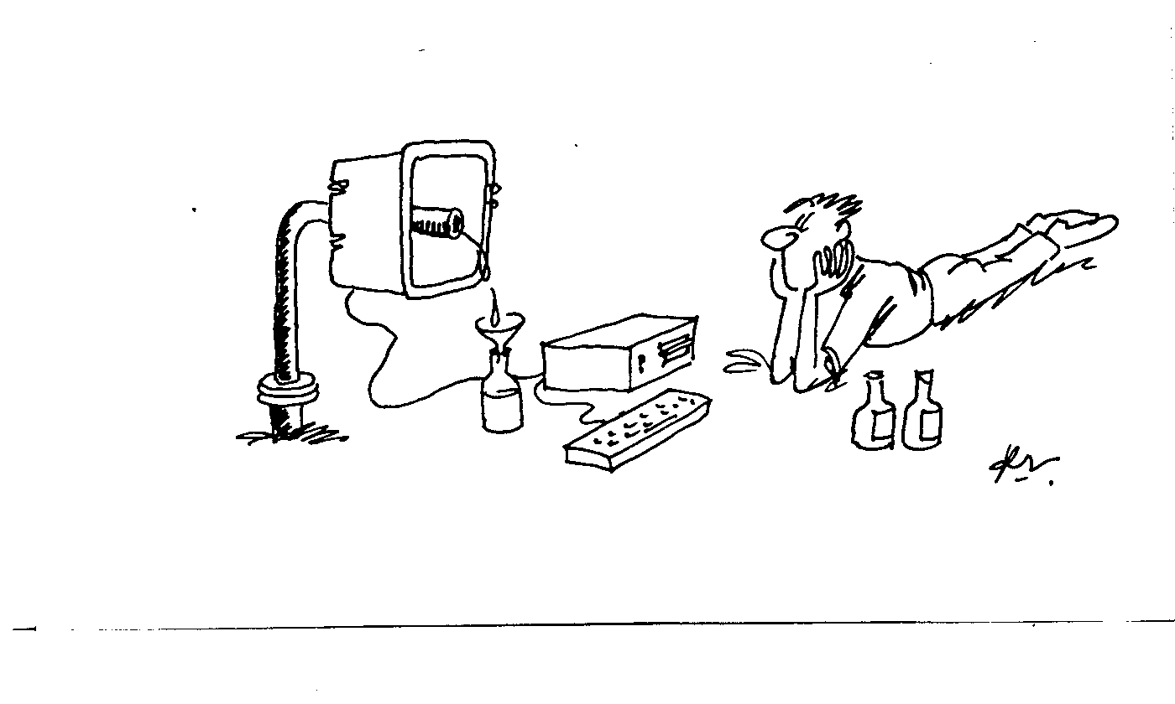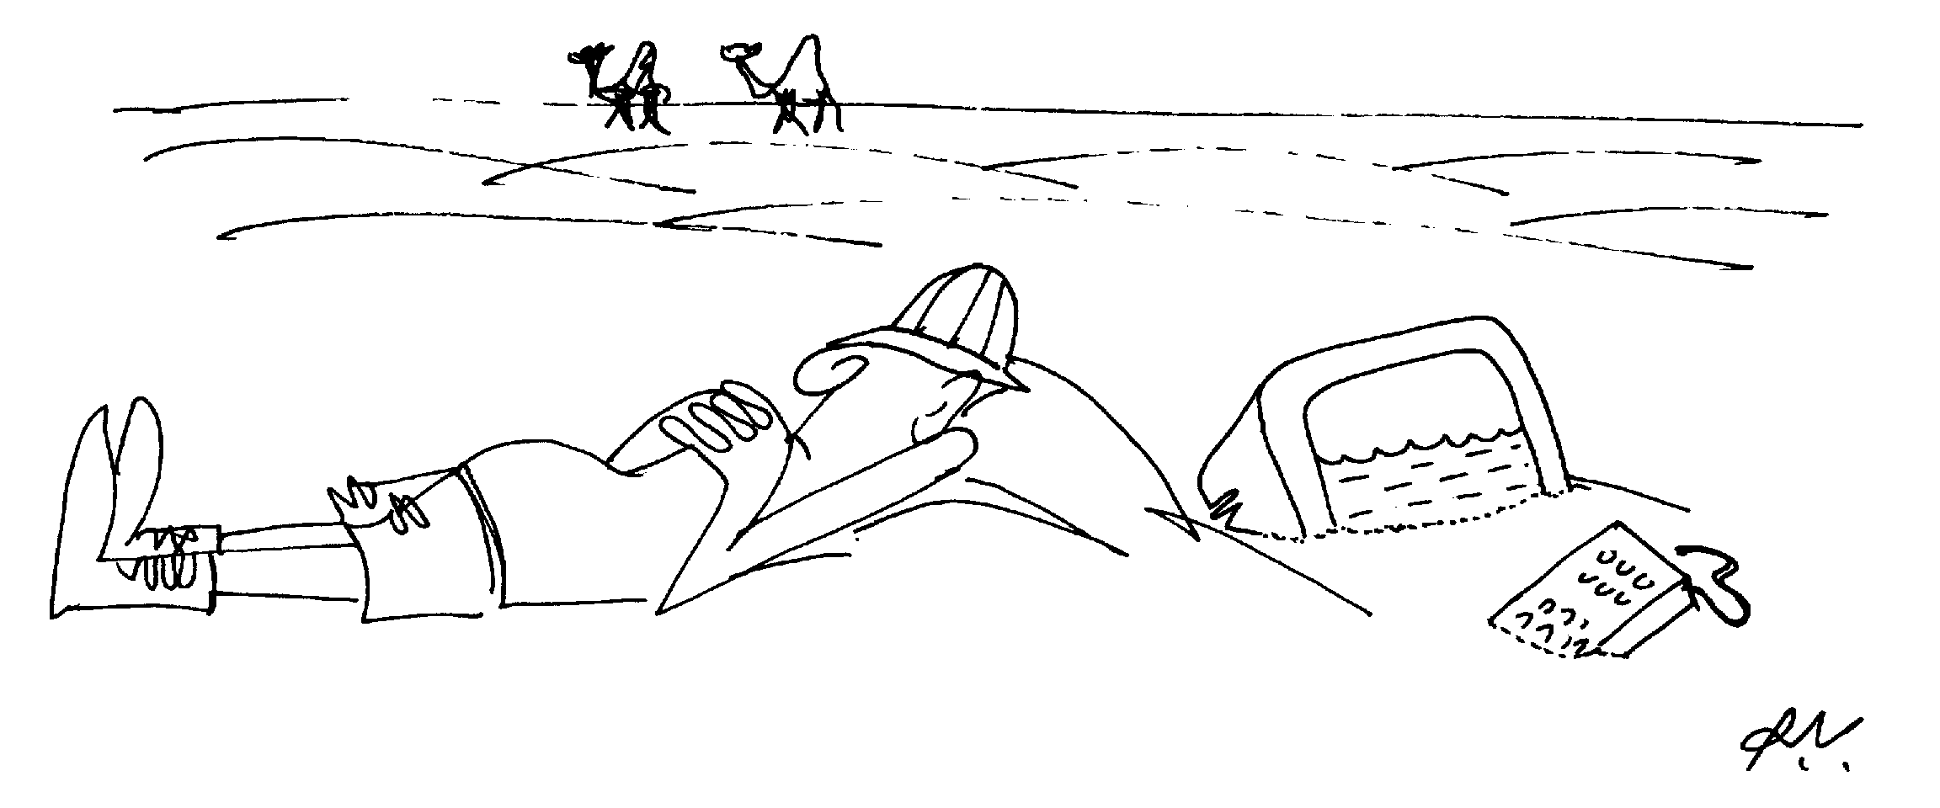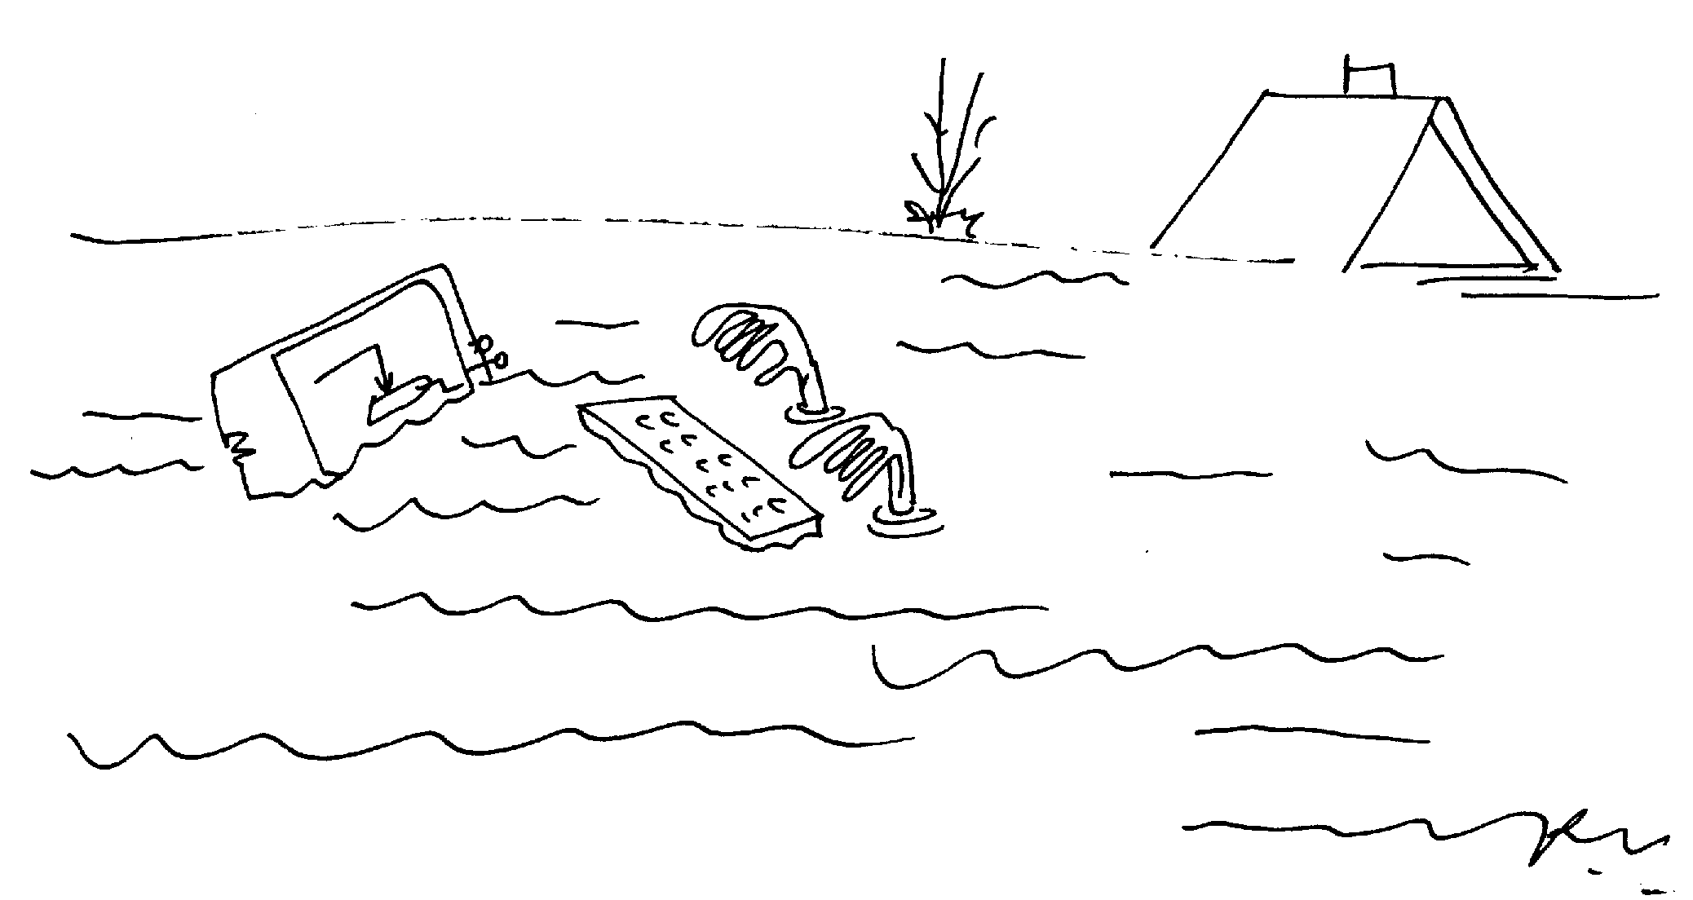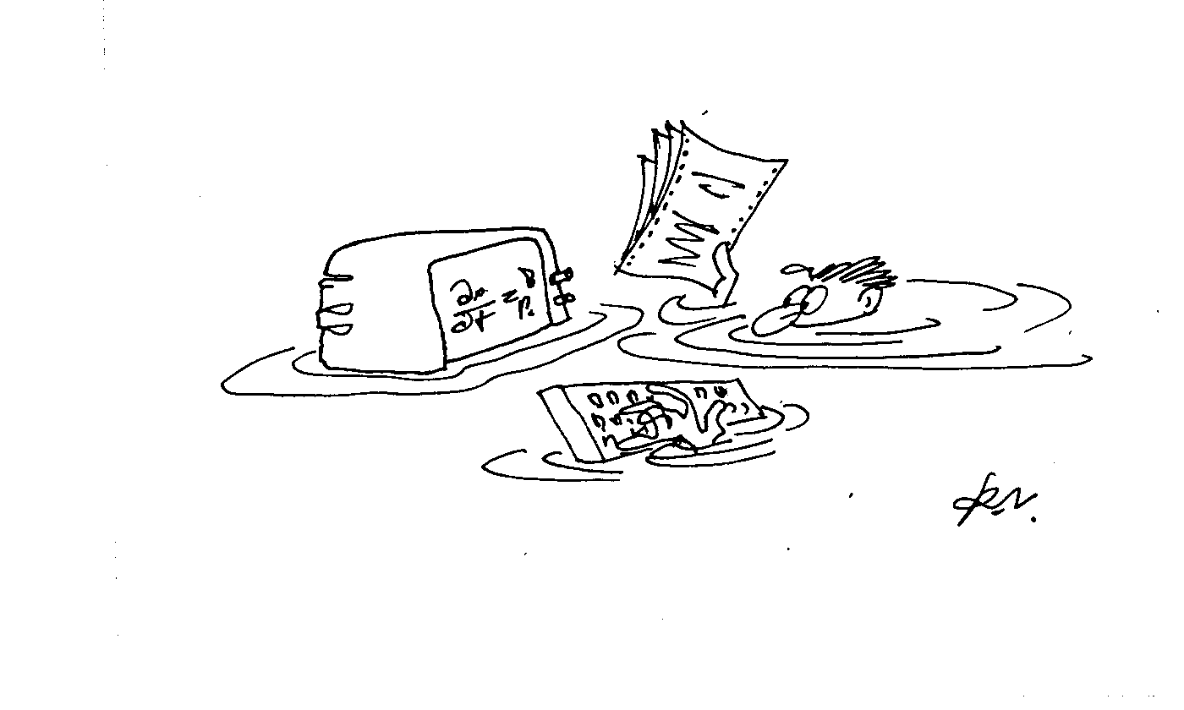
Drawings of leading Latvian cartoonist - Romans Vitkovskis

Aivars Spalvins
Address:1/4 Meza Str.,
Riga, LV-1048, Latvia
E-mail: emc@egle.cs.rtu.lv
http:// www.emc.rtu.lv

